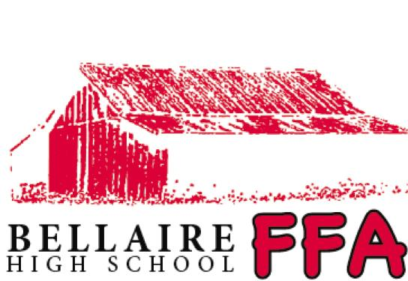

Parents Night Out

Would you like a date night, time for holiday shopping or simply relaxing at home?

Your child is invited to be an honorary student of the Bellaire FFA for the evening!

WELCOME TO THE FARM!!

Ages: 5-12
Date: Saturday, December 14, 2013
Time: 6 pm-10 pm
Place: 11611 Riceville School Road
Houston, Texas 77031
Cost: $40 per child, $35 for each add’l sibling (if pre registered by Dec 7)
$45 per child, $40 per each sibling (after Dec 7)

Your child will enjoy a fun filled evening! Events subject to change:

Pizza Team Building games Water Petting zoo
S’mores Hay ride
Popcorn/Cotton Candy Animal grooming
Hot chocolate “G” rated movie under the stars
Candy Bar Honorary FFA member t-shirt

Questions: E-mail Judi Underwood at alumni.bellaireffa@yahoo.com or call 832-428-1089.

Make Checks payable to Bellaire FFA Alumni Assoc.
Fill out form COMPLETELY and return with payment to:
Bellaire FFA Alumni Assoc.
PO Box 2311
Bellaire, TX 77402

FOR QUESTIONS, please e-mail Judi Underwood at alumni.bellaireffa@yahoo.com
or call 832-428-1089
PARTICIPANT INFORMATION - First Child

Last Name ____________________________________ First Name __________________________________ Age ________________

Address _______________________________________ City ______________________________ State _______ Zip ______________

Phone Number _______________________________ E-mail _____________________________________________________________

Emergency Contact _____________________________________ Emergency Contact Number __________________________

T-Shirt Size: Youth ___ Small ___ Medium ___ Large ___ X-Large

Adult ___ Small ___ Medium ___ Large ___ X-Large

PARTICIPANT INFORMATION - Second Child - please copy this form for additional siblings

Last Name ____________________________________ First Name __________________________________ Age ________________

T-Shirt Size: Youth ___ Small ___ Medium ___ Large ___ X-Large

Adult ___ Small ___ Medium ___ Large ___ X-Large

PARENT/GUARDIAN INFORMATION

Last Name ____________________________ First Name _________________________ E-Mail ______________________________

Home Phone Number ____________________________________ Cell Number __________________________________________

Cost: $40 1st Child $35 each add'l sibling TOTAL COST: ______________________

Cost after December 7th - $45 1st Child $40 each add'l sibling (T-shirt may not be available but can be ordered). Event to be held, rain or shine, but events may differ.

DISCLAIMER: To the best of my knowledge, my child can fully participate in this activity. I am fully aware of risks and hazards connected with the activity, including but not limited to the risks as noted herein, and I hereby elect to voluntarily participate in said activity, and to enter the above-named premises and engage in such activity knowing that the activity may be hazardous to me and my property. THEREFORE, I VOLUNTARILY ASSME FULL RESPONSIBILITY FOR ANY RISKS OF LOSS, PROPERTY DAMAGE OR PERSONAL INJURY, that may be sustained by me, or any loss or damage to property owned by me, as a result of being engaged in such activity, WHETHER CAUSED BY THE NEGLIGENCE OF RELEASEES or otherwise. I further hereby AGREE TO INDEMNIFY AND HOLD HARMLESS THE RELEASEES from any loss, liability, damage or costs, including court costs and attorney's fees, that may incur due to my participation in said activity, WHETHER CAUSED BY NEGLIGENCE OF RELEASEES or otherwise.

