November 10, 2015

Feeder,

Attached you will find an entry form for the Bellaire FFA Showmanship Clinic and the Bellaire FFA Progress Show.

The Showmanship Clinic is tentatively scheduled for Saturday, January 9, 2016 starting at or about 8:00am based on the weather. The tentative show order is goats, lambs then heifers followed by steers and hogs. There is a $10.00 entry fee in CASH per species to exhibit your project(s) at this show. The entry fee will be used to pay for the judge. You must turn in this entry form along with your cash payment to the agriculture department by the end of the school day on Wednesday, December 9, 2015.
NO FORM, NO PAYMENT, NO SHOW! The show will start at or about 8:00am.

The Bellaire FFA Progress Show is tentatively scheduled for Saturday, February 6, 2016 starting at or about 8:00ambased on weather. The tentative show order is goats, lambs then heifers followed by steers and hogs. There is a $10.00 entry fee in CASH per species to exhibit your project at this show. There is no cost for the parents to show. The entry fee will be used to pay for the judge as well as any additional awards that may be given out per species show. You must turn in this entry form along with your cash payment to the agriculture department by the end of the school day on Tuesday, January 19, 2016. NO FORM, NO PAYMENT, NO SHOW! The show will start at or about 8:00am.

Neither the Showmanship Clinic of Bellaire FFA Progress Show are mandatory. These are just opportunities available to you to gain valuable knowledge and show experience before either the Bellaire FFA Progress Show in February or the Bellaire FFA Livestock Show in April.

Please feel free to contact the agriculture department if you have any questions or just need more information about this show.

Thanks,

Ag Department

Bellaire FFA Showmanship Clinic
January 9, 2016

The Showmanship Clinic is tentatively scheduled for Saturday, January 9, 2016 starting at or about 8:00am based on the weather. There is a $10.00 entry fee per species in CASHto exhibit your project at this show. The entry fee will be used to pay for the judge(s). You must turn in this entry form along with your cash payment to the agriculture department by the end of the school day on Wednesday, December 9, 2015. NO FORM, NO PAYMENT, NO SHOW! Show date is tentative based on weather! The show will start at or about 8:00am and the following is the tentative show order for the day:

Goats – 8:00am
**Followed By**
Lambs
**Followed By**
Heifers
**Followed By**
Steers
**Followed By**
Hogs

Name:_________________________________________________________________________

Type of Animal: (Circle) Goats Lamb Heifer Steer Hog

Exhibitor/family must own animal being shown.

ALL ENTRY FORMS ARE DUE BY ON THE END OF THE SCHOOL DAY ON WEDNESDAY, December 9, 2015.

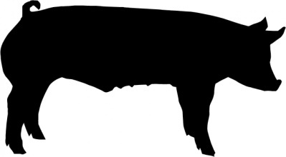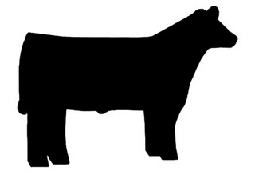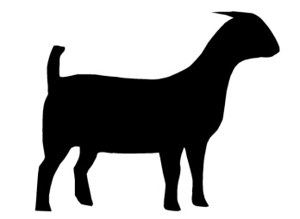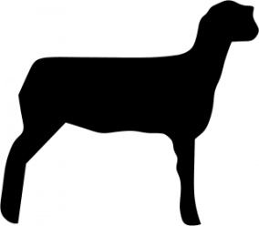
Bellaire FFA Progress Show
February 6, 2016

There is a $10.00 entry fee per species in CASH to show at this show. These funds will be used to pay for the judge(s) as well as the awards that will be given out per species. You must turn in this entry form along with your cash payment to the agriculture department by the end of the school day on Tuesday, January 19, 2016. NO FORM, NO PAYMENT, NOSHOW! Show date is tentative based on weather! The show will start promptly at or about 8:00am and the following is the tentative show order for the day:

Goats – 8:00am
Parent Showmanship Show – no cost to enter
Lambs
Parent Lamb Showmanship Show – no cost to enter
Heifer
Steers
Parent Cattle Showmanship Show – no cost to enter
Hogs
Parent Hog Showmanship Show – no cost to enter

Name:_________________________________________________________________________

Type of Animal: (Circle) Goats Lamb Heifer Steer Hog

Exhibitor/family must own animal being shown.

ALL ENTRY FORMS ARE DUE BY ON THE END OF THE SCHOOL DAY ON TUESDAY, January 19, 2016.

