**Division I – Breeding Heifers**

This division is subject to the general rules and the following division rules.

1. Each breed division will be divided according to age and number of heifers entered to be determined by Bellaire Agriculture Science Instructor(s).
2. There will be four (4) breed divisions to include American, British, Exotic, and ORB (other registered breeds) to be shown in the above stated order.
3. A copy of the registration paper must be submitted with entry form.
4. Students must pay a $20.00 entry fee per heifer shown by the end of the Tuesday, March 10, 2015 FFA Meeting.
5. Heifer show is a blow and go show.
6. Heifers must be healthy at show time or they will not be permitted to show.
7. All heifers must be controlled by the exhibitor in the show ring or they will be removed from the show ring. Dismissal will be determined by the judge and Bellaire Agriculture Science Instructor(s).
8. One overall Grand and Reserve heifer will be awarded.
9. Breeding Heifers will not be sold in the Auction.
10. Each breeding heifer will need to be registered in the student’s name by November 1st.
11. Heifers must be born after September 1, 2012.
12. Agriculture Instructor(s) reserves the right to add, amend or modify any rules on an as need basis.

**Division II – Broilers**

This division is subject to the general rules and the following division rules.

1. Birds must be purchased through the Bellaire Agriculture Department and must have a wing band present on the birds at show time.
2. Each student must purchase 25 birds. Each exhibitor may purchase up to two lots of 25, or 50 birds total.
3. Broilers will be wing banded upon delivery, and those that show at the Bellaire FFA Livestock Show must have the appropriate band present on the bird.
4. Broiler entries are limited to one pen of three birds per exhibitor.
5. All three birds must be healthy at show time.
6. Broiler entries can be cockerels or pullets.
7. Exhibitors will be allowed to present only three birds for judging. No substitutes or alternate birds are allowed after the judging begins.
8. Only the Grand and Reserve poultry will be displayed upon conclusion of judging. The Grand and Reserve exhibitors must provide their own feeder and waterier. They are also responsible for feeding and watering their birds.
9. All broilers will be processed during the show, and the exhibitor is responsible for delivering the processed birds to the buyer within one week after the show if they are not picked up during the show.

**Division II – Horticulture Rules**

This division is subject to the general rules and the following division rules.

1. Students may show one project per division. Each entry will be $20.00 and is due by the end of the Tuesday, March 10, 2015 FFA Meeting.

2. Students must be FFA members of the Bellaire FFA Chapter and meet UIL eligibility.

3. Students will be required to pre-register their entries by the end of the March 10, 2015 FFA Meeting to exhibit their project at the Bellaire FFA Livestock Show.

4. Exhibits must be checked in by the student at the Bellaire Agriculture Complex by 5:00pm on Wednesday, April 8, 2015. Judging will begin at approximately 5:30pm on Wednesday, April 8, 2015.

5. No students will be allowed in the judging are or to interrupt the judge during the judging.

6. Exhibitors must submit a portfolio containing photos of the project’s creation, showing the student. The portfolio must contain a minimum of 5 photos showing different stages of

development with descriptions. Students must also include a bill of materials for the project.

7. Entries may not be of a size larger than the exhibitor is able to hand carry into the auction ring. If the project does not meet this requirement, it will be disqualified from the show.

8. Student must determine which division the project is to be exhibited in at the time of entry.

9. Awards for projects in each Division will be awarded.

10. A Grand and Reserve project in each Division will be selected.

11. An Overall Grand Champion and Overall Reserve Champion will be chosen from all Divisions combined.

12. Only the Overall Grand and Reserve Champion horticulture projects will be eligible to be sold through the live auction.

**Horticulture Divisions**

1. Fresh Flower Arrangement

Any type of fresh flower arrangement that is created by the student.

2. Dish Garden / Terrarium

Dish Gardens must be exhibited in a dish type container.

Terrariums must be exhibited in a covered or closed container for growing plants created by the student.

3. Other

May include silk, dried, wreaths, etc. projects created by the student.

**Division IV – Market Goats**

This division is subject to the general rules and the following division rules.

1. Market Goats will be divided into an equal or nearly equal number of per class according to weight.
2. Goats will be handled with a collar or chain. No harnesses or halters are allowed.
3. All goats must be dehorned prior to the show, with any tipped horns not being smaller than a dime in circumference.
4. All goats must be slick shorn to the skin above the knee and hock joints.
5. Minimum weight must be 70 pounds to be exhibited at the Bellaire FFA Livestock Show
6. Unhealthy goats will not be permitted to show.

**Division V – Swine**

This division is subject to the general rules and the following division rules.

1. The division will be divided into an equal or nearly equal number of swine per class according to weight.
2. Swine entries may be barrows and/or gilts.
3. Swine must be thoroughly cleaned at show time or they will not be permitted to show.
4. No oil, paints, or powder will be permitted.
5. Swine must be healthy at show time or they will not be permitted to show.
6. Minimum weight must be at least 220 pounds with no maximum weight to be exhibited at the Bellaire FFA Livestock Show.

**Division VI – Lambs**

This division is subject to the general rules and the following division rules.

1. Lamb entries may be either whether or ewe lambs.
2. All lambs must be slick shorn.
3. Lambs will be divided into an equal or nearly equal number of lambs per class according to weight.
4. The use of a hot shot or any electric prod is prohibited at the Livestock Show.
5. No painting or changing color will be allowed.
6. Halters or collars on lambs will not be allowed in the show arena.
7. Unhealthy lambs will not be permitted to show.
8. Minimum weight must be 110 pounds to be exhibited at the Bellaire FFA Livestock Show

**Division VII – Steers**

This division is subject to the general rules and the following division rules.

1. Steers will be classified by weight. The steers will be divided into equal or nearly equal-sized classes according to number of entries and weight.
2. The Bellaire FFA Livestock Steer Show is a “Blow and Go Show”. No Adhesives allowed. Hair and skin conditioners are allowed.
3. No hair shall be longer than ¼”. Hair shall be allowed on the switch of the tail. Any hair found to be longer than ¼” must be clipped prior to entering the show ring.
4. No change of the major color pattern of the animal by painting or dying will be allowed. Any exhibitor using grooming material that allows color to come off will disqualify the steer from competition.
5. All steers must be dehorned.
6. Steers must be healthy at show time or they will not be permitted to show.
7. Minimum weight must be 1,000 pounds to be exhibited at the Bellaire FFA Livestock Show
8. All steers must be controlled by the exhibitor in the show ring or they could be removed from the show ring. Dismissal will be determined by the judge and/or any Bellaire Agriculture Science Instructor.

**Division VIII – Visual Arts**

This division is subject to the general rules and the following division rules.

1. All entries in this division are subject to the general rules and the following Visual Art rules.
2. Students must pay a $20.00 entry fee per project shown by the end of the Tuesday, March 10, 2015 FFA Meeting.
3. No team entries allowed.
4. There are Five (5) classes in this division.
   * Class 1: Photography = One black and white print of a person, place, or thing
   * Class 2: Photography = One color print of a person, place, or thing
   * Class 3: Photography = One photo story, 3 to 6 photos mounted on one mat board. Each photo will be no larger than 4” x 6”. The art board will be no larger than 16” x 20”.
   * Class 4: Photography = One black and white print of a person, place, or thing that has not been altered from the original outcome
   * Class 5: Two Dimensional =
     1. Oil – work may be on any prepared surface.
     2. Acrylic, Watercolor – tempra, gouache, casein
     3. Pencil, Pastels, Crayon and Charcoal – must be protected with cellophane.
     4. Ink Drawings – may include colored ink and felt tip drawings.
     5. Mixed Media – two or more media combined in a single two-dimensional art.
5. No more than one entry per class per exhibitor.
6. No students will be allowed in the judging are or to interrupt the judge during the judging.
7. The Bellaire FFA, Bellaire Booster Club, Bellaire High School nor HISD will not be responsible for any damage or loss of a project while it is being displayed, judged, or moved on the school grounds.
8. Overall Grand and Reserve Champion Visual Art Project will sell in the live auction and must be placed into an appropriate frame by the day of the live auction.

**Picture/Photography Rules:**

1. Photographs must be no smaller than 5” x 7” or larger than 8” x 10”. The 5” x 7” photograph will be securely mounted on art board no larger than 8” x 10”. The 8” x 10” photograph will be securely mounted on art board no larger than 11” x 14”. Flush mounting is acceptable (photographs must be even with edge of art board). Photographs may be matted but mat may not exceed maximum size of 11x14 after matting. Optional: Photograph may have a “Title” on the front.
2. Photographs must be mounted on art board with no frames or glass. Two Dimensional Art may be mounted but not framed.
3. Two Dimensional Art may be matted but may not exceed 16” x 20” without mat.

Bellaire FFA Advisor(s) and/or Bellaire High School Administration shall be the final authority of these rules and regulations and shall arbitrarily settle and determine all matters, questions, and differences in regard thereto or otherwise arising out of connection with, or incidental to the show.

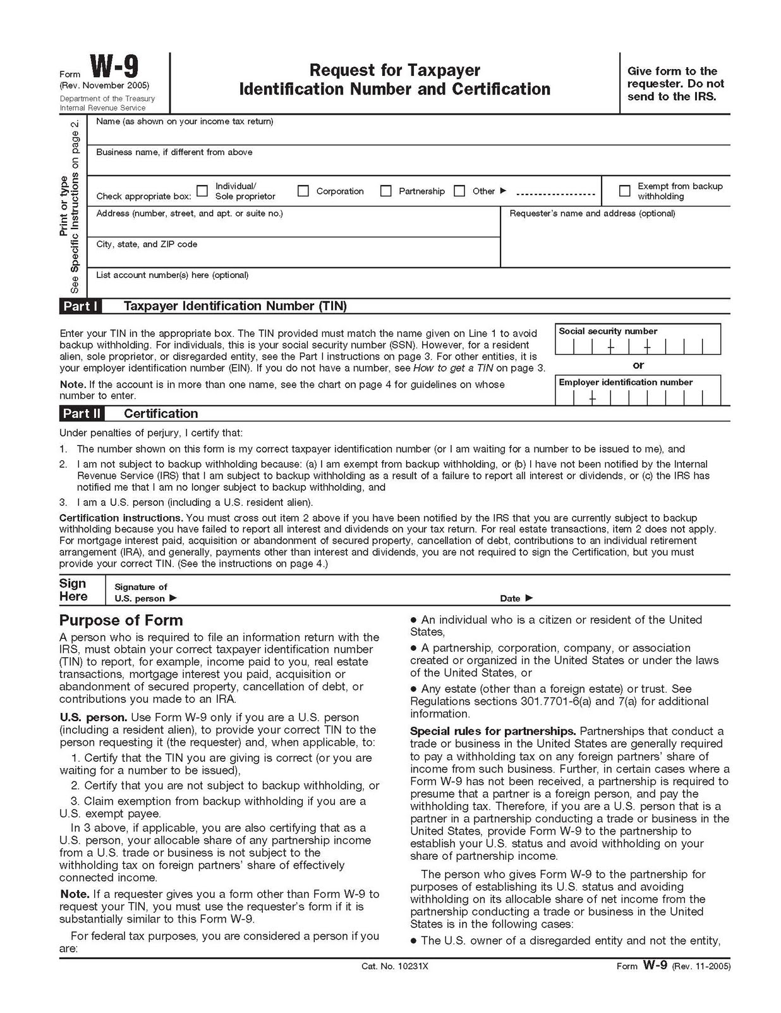

**Bellaire FFA LIVESTOCK SHOW HEIFER, HORTICULTURE AND VISUAL ARTS ENTRY FORM**

Exhibitor Name: ______________

Address: ______________

City, State, Zip: ______________

Phone: Age: Grade:

**********************************************************************************

**Only one entry per class/division – $20.00 per project entered.**

( ) Heifer _____ American _____ British _____ European ______ ORB

1st Heifer Age: ____________ Division (1) ______ 18 months in age or younger

Division (2) ______ 19 months in age or older

Breed: ____________________________________________________________________________

( ) Heifer _____ American _____ British _____ European ______ ORB

2nd Heifer Age: ____________ Division (1) ______ 18 months in age or younger

Division (2) ______ 19 months in age or older

Breed: ____________________________________________________________________________

( ) Horticulture Class 1 _____ Class 2 _____

Class 3 _____ Class 4 _____

Class 5 _____

( ) Visual Art Class 1 _____ Class 2 _____

Class 3 _____ Class 4 _____

Class 5 _____

**********************************************************************************

Student Signature: _________________________ Parent Signature: ________________________________

Amount Paid: $ _____________Check # ____________Cash: _________Receipt # _____________________

**Entry Deadline is by the end of the Tuesday, March 10, 2015 FFA Meeting.**

The Houston Independent School District, Bellaire High School, Bellaire FFA, Bellaire FFA Booster Club nor any of its employees and/or appointed Show Officials will not be liable for any damage(s) resulting from fire, theft, accident, injury or any other adverse situation. **Exhibitor and Parent or Legal Guardian** agrees to abide by all Rules and Regulations of the **Bellaire FFA Livestock Show and Auction.**